Azamat Salamatov

Dr. Hoang Nguyen

MATH 2317 – 1

Assignment 1

February 17, 2023

Homework – 1

1.

a) Is there an integer n such that n has a remainder 1 when it is n/4, and a remainder 3 when n/7?

b) Does there exist and integer n such that if n is divided by 4 the remainder is 1 and if n is divided by 7 the remainder is 3?

2.

a) a positive real number s such that s is smaller than r.

b) positive real number r, there is a positive real number s such that s<r.

3. Some integer has a reciprocal of itself that is also an iteger.

4.

a) All triangles have 3 sides.

b) Every triangle has 3 sides.

c) … has 3 sides.

d) If T is a triangle, then T has 3 sides

e) … T has 3 sides.

5)

a) … have additive inverses.

b)… an additive inverse for x.

c) … y is an additive inverse for x.

6)

a) … less than or equal to every positive integer.

b) … a positive integer m such that m is less than or equal …

c) … m is less or equal to n.

7)

a) a set of all integers such that every element of the set is a factor of 9.

b) {-9, -3, -1, 1, 3, 9}.

8)

a) No. there is no set {5} in set {1,3,5}, there is only element 5.

b) Yes, {5} is a subset of {1,3,5}, element of {5}, 5, is also in {1,3,5}

c) Yes. {5} is an element of the bigger set.

d) No. element 5 is not in the bigger set.

9)

a) {(a,u),(a,v),(b,u),(b,v),(c,u),(c,v)}

b) {(u,a),(u,b),(u,c),(v,a),(v,b),(v,c)}

10)

a) yes, 15/3=5

no, there is no relation

no, there is no relation

yes, 18/3 = 6

b) R = {(3,15),(5,15),(3,18)}

c) Domain of R = {3,5,7}, co-domain of R = {15,16,17,18}

d) 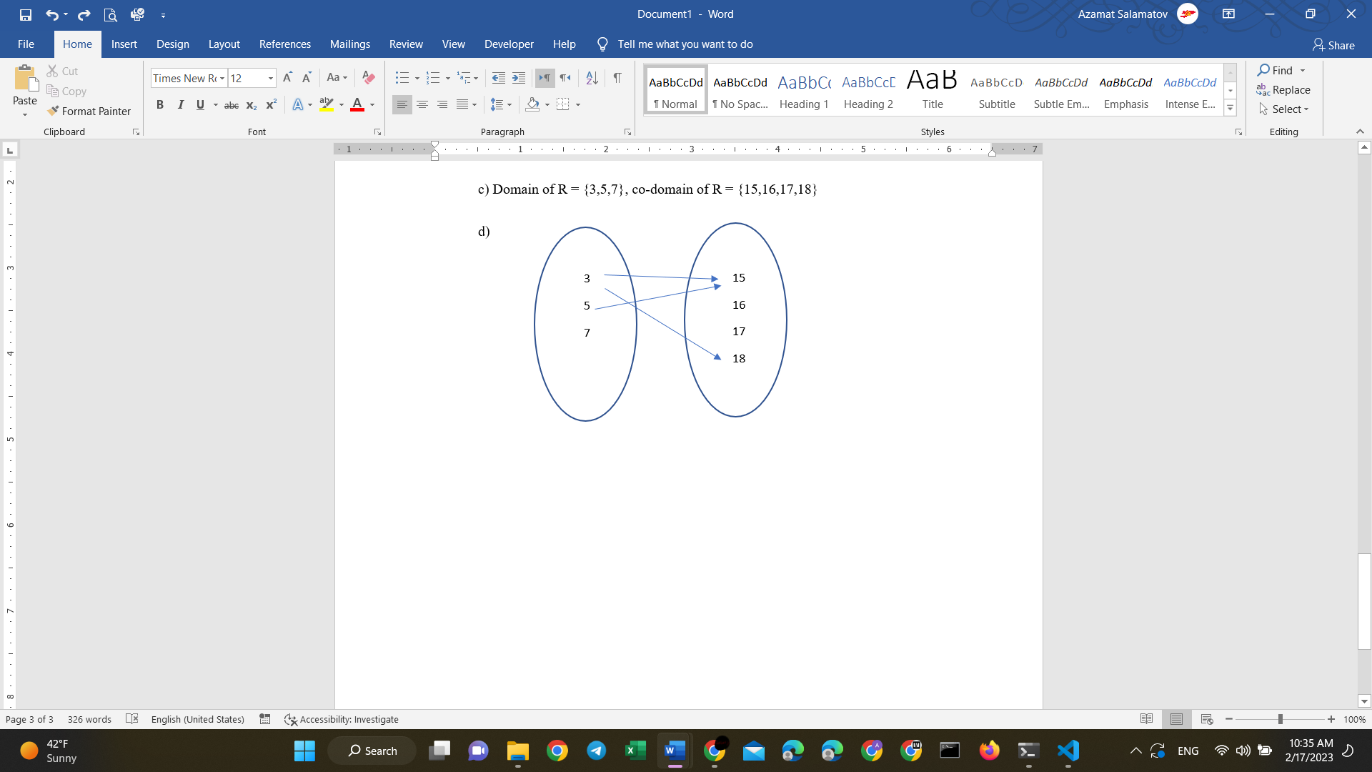

e) No, 3 has two arrow to 15 and 18. R is not a function from A to B.

11)

a)No, 2 not equals 26

Yes, 5=22+1

No, -3 not equal 101

Yes, 10 = (-3)2+1

b) 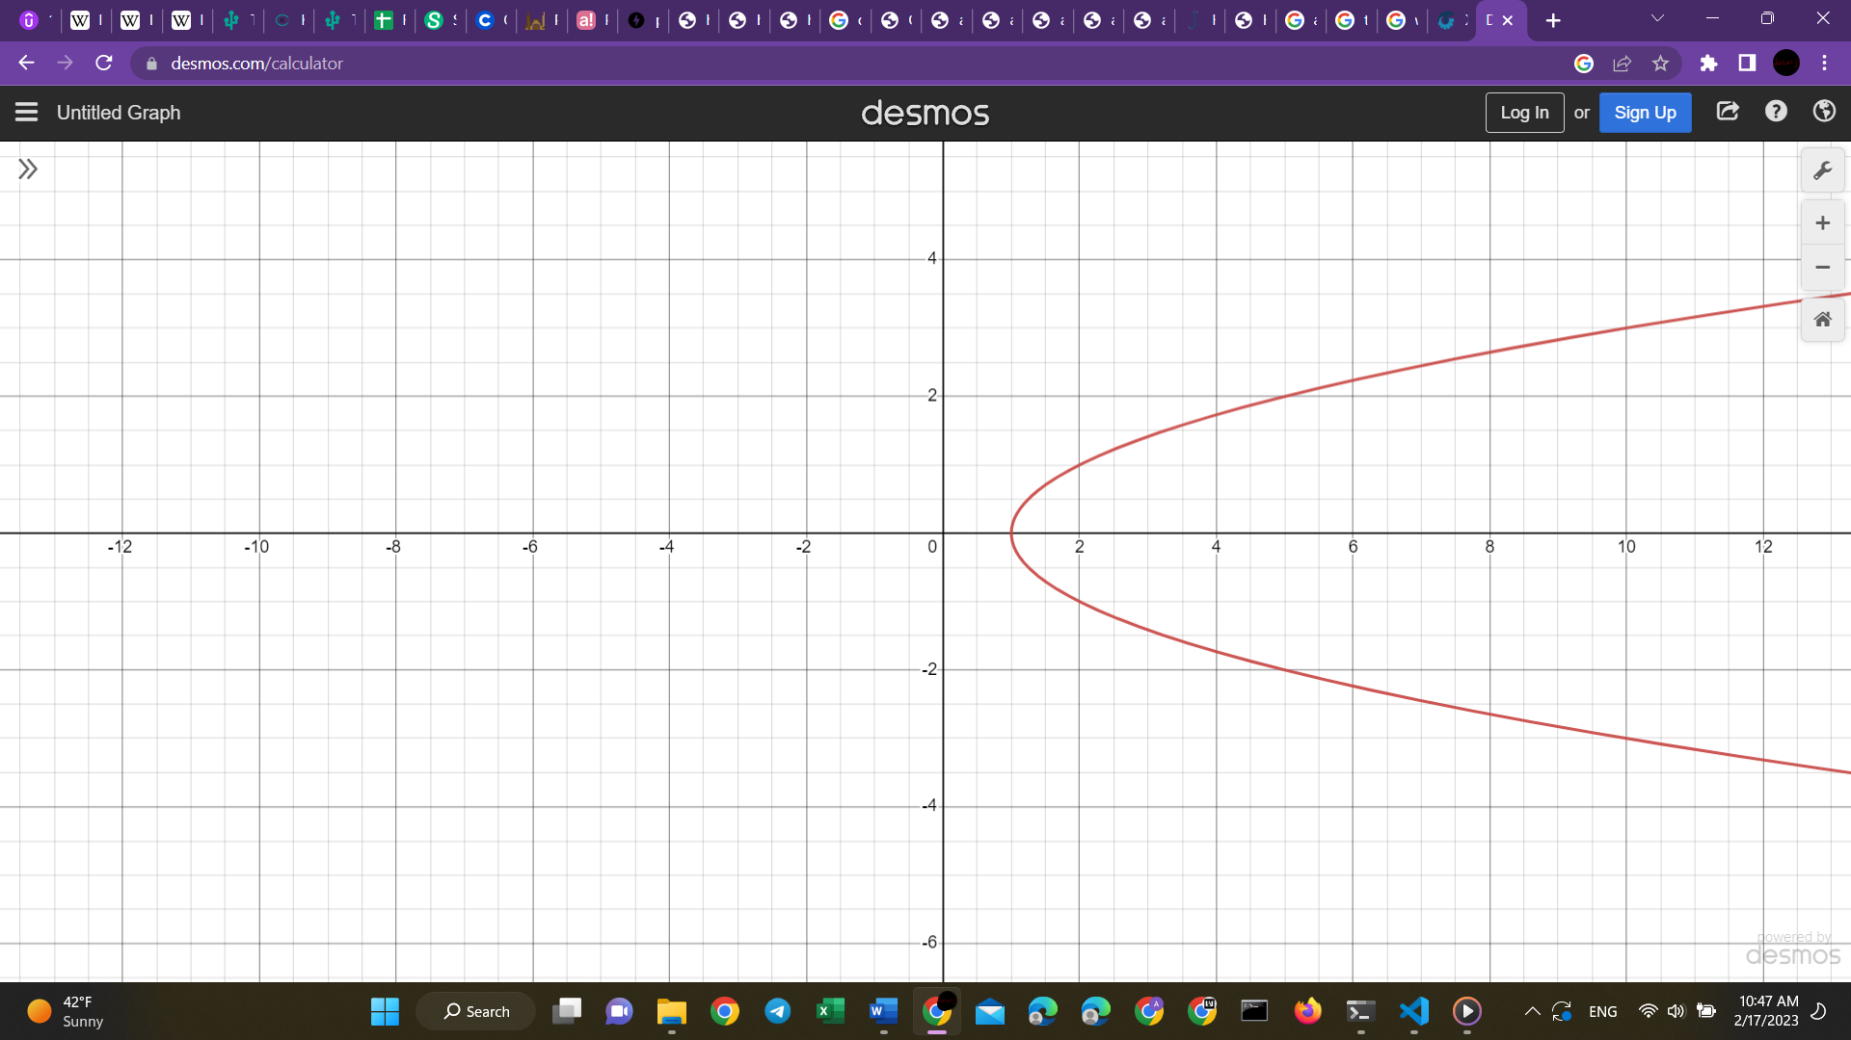

c) No, there there is more than one point for x. Ex: when x = 5, there are two value for y: 2, -2.

12)

a) G(2) = c

b) 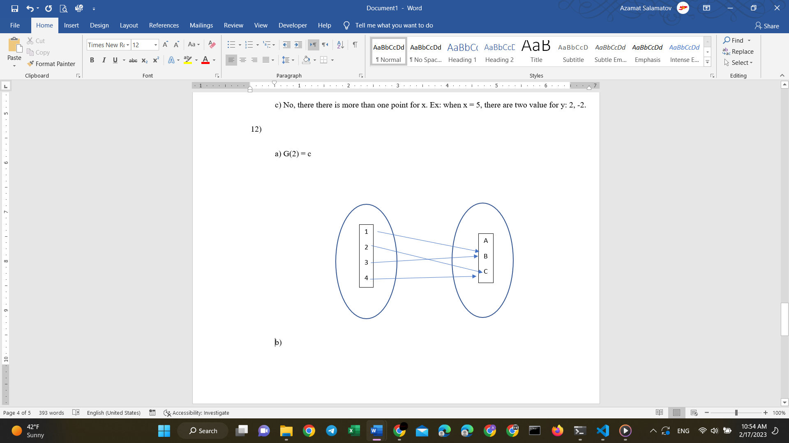

13) No, if we try to solve:

F(x)=G(x)

(x+1)(x-3)=(x-2)2 -7

x2 -2x -3 = x2 -4x -3

~~x~~~~2~~ -2x ~~-3~~ = ~~x~~~~2~~ -4x ~~-3~~

they are not equal

so, F not equal to G.